|  |  |
| --- | --- |
| EGC_Black | Student Name \_\_\_\_\_\_\_\_\_\_\_\_\_\_\_\_\_\_\_\_\_\_\_    **Eastern Goldfields College**  Mathematics U1&2 2017  Assignment – Calculator Free1 |
|  | Total Marks: 14 marks |

**Time allowed: 15 minutes**

***Answer all of the following questions. Show all working to obtain full marks.***

Question 1 (6 marks)

1. A straight line has equation $y=4-2x$. Determine:  
   1. the coordinates of the y-intercept. (1 mark)
   2. the slope of the line. (1 mark)
   3. the coordinates of the x-intercept. (1 mark)

1. Draw the line with equation $y= -\frac{1}{2}x+1$ on the axes below. (3 marks)

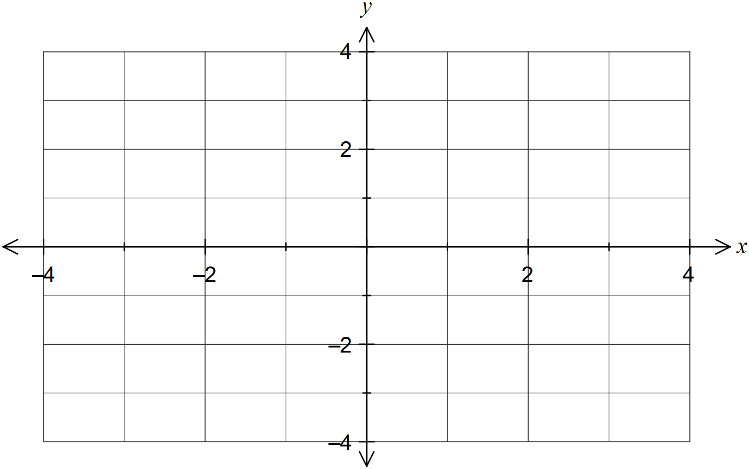

Question 2 (8 marks)

Four matrices are given by $A= \left[\begin{matrix}-1 & 1 \\ 1 & 2\end{matrix}\right] , B=\left[\begin{matrix}2 \\ -3\end{matrix}\right] , C = \left[\begin{matrix}-2 & 1\end{matrix}\right] , and D= \left[\begin{matrix}2 & 1 \\ -1 & 4\end{matrix}\right]$.

(a) State the size of the column matrix. (1 mark)

(b) If possible, calculate the following. If not possible, explain why.

(i) $A+D$. (1 mark)

(ii) $5C$. (1 mark)

(iii) $B-C$. (1 mark)

(iv) $AB$. (1 mark)

(b) If $CD- \left[\begin{matrix}2 & e\end{matrix}\right]= \left[\begin{matrix}f & -1\end{matrix}\right]$, determine the values of $e$ and $f$. (3 marks)

|  |  |
| --- | --- |
| EGC_Black | Student Name \_\_\_\_\_\_\_\_\_\_\_\_\_\_\_\_\_\_\_\_\_\_\_    **Eastern Goldfields College**  Mathematics U1&2 2016  Test 2 – Calculator Assumed1 |
|  | Total Marks: 18 marks |

**Time allowed: 20 minutes**

**Calculator only, NO notes permitted for this section.**

***Answer all of the following questions. Show all working to obtain full marks.***

Question 3 (10 marks)

The weights of boys and girls who take part in a gymnastics program are summarised in the table below.

|  |  |  |  |  |  |  |
| --- | --- | --- | --- | --- | --- | --- |
| Weight (Kg) |  |  |  |  |  |  |
| Boys | 16 | 116 | 186 | 152 | 68 | 15 |
| Girls | 10 | 80 | 47 | 45 | 20 | 6 |

(a) Are weights an example of categorical, continuous or discrete data? Justify your answer.

(2 marks)

The mean and standard deviation of the boy's weights is 43.3 and 11.1 kg respectively.

(b) Calculate the mean and standard deviation of the girl's weights. (2 marks)

The graph below shows the weight distribution of the boys.

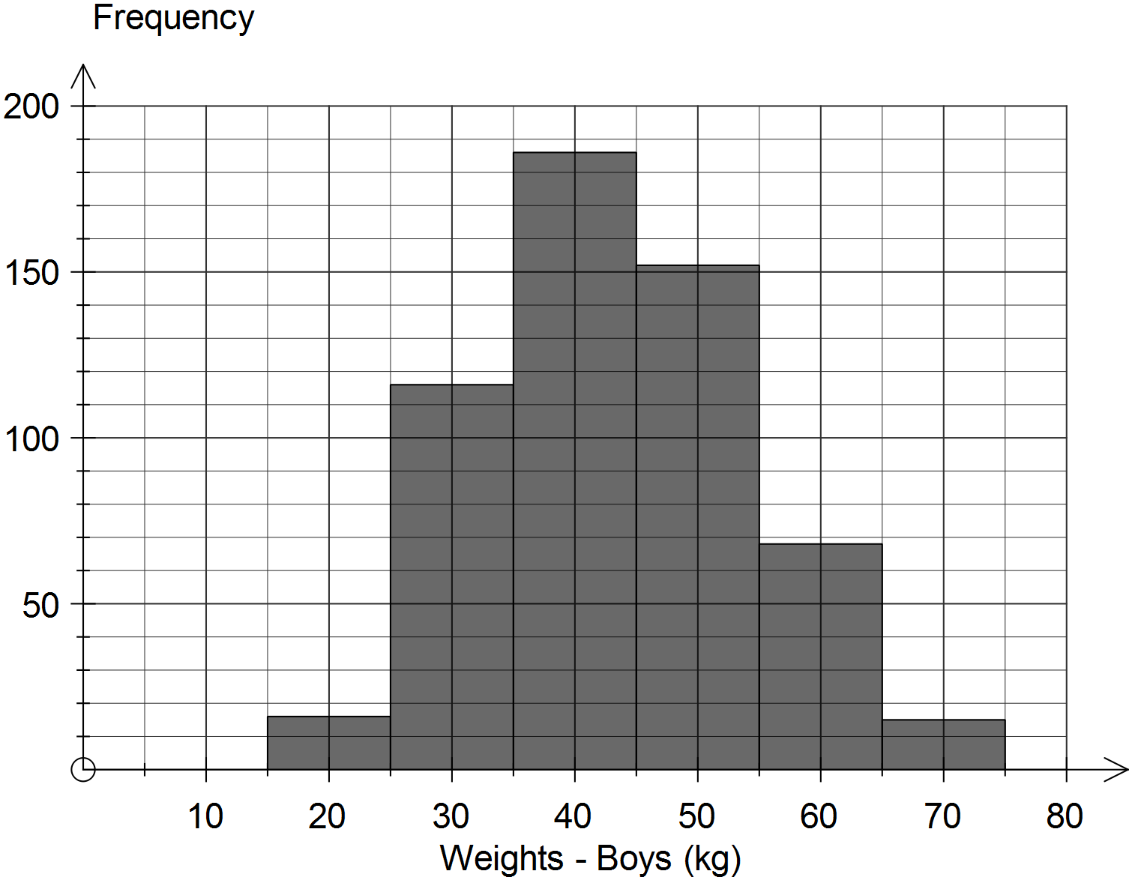

(c) Describe the modality of the distribution of the weights of boys. (1 mark)

(d) Complete the histogram below to show the weight distribution of the girls.

(2 marks)

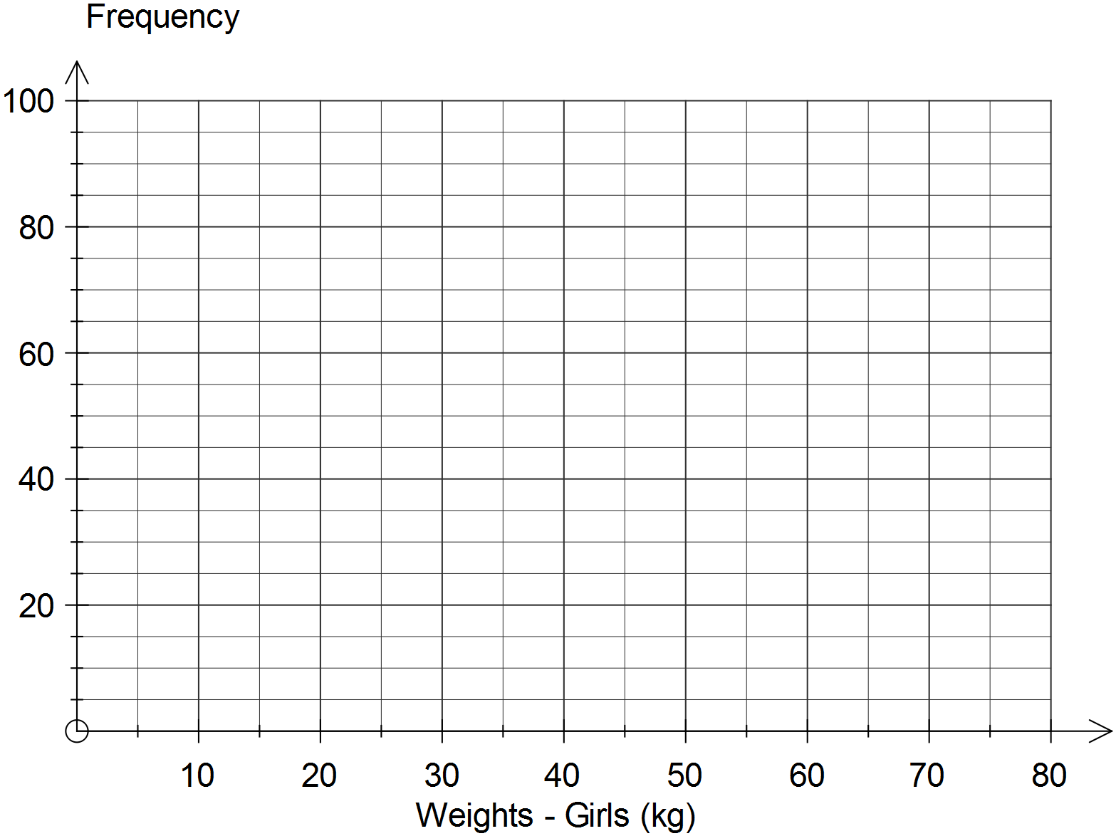

(e) Use the information in this question to comment on any similarities or differences between the weights of boys and girls who take part in the gymnastics program. (3 marks)

Question 4 (8 marks)

A shopper found the same item on three different websites, as shown in the table below. The total cost to the shopper is the price of the item plus shipping.

|  |  |  |  |
| --- | --- | --- | --- |
| Location of website | Australia | Great Britain | Hong Kong |
| Local currency | Australian dollar  AUD | Great Britain pound  GBP | Hong Kong dollar  HKD |
| Item cost in local currency | 148.95 | 79.95 | 995 |
| Shipping cost | 11.95 | 7.95 | 149 |

At the time, the exchange rates for one Australian dollar were 0.5931 GBP and 5.6806 HKD.

(a) Determine the total cost of the item from the Australian website. (1 mark)

(b) The shipping cost for the Australian website is close to 8% of the item cost. Determine for which website the shipping cost is the highest as a percentage of the item cost, and state what this percentage is. (2 marks)

(c) Determine the website that offers the lowest total cost for the item in Australian dollars. Justify your answer. (4 marks)

(d) The item cost in Australian dollars includes GST of 10%. Determine the amount of GST included in the item cost. (1 mark)

* END OF TEST -